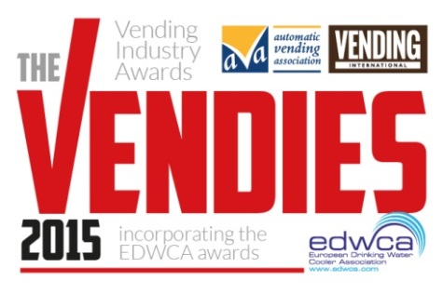
The Vendies 2015
Entry Form
Ingredients & Supplier Awards

Section 1: Your details (simply type over the grey area)

First name |  | Surname
Job title
Company
Address
 |  | Postcode
Telephone
E-mail

Section 2: Categories: (tick all that apply)

Best Ingredient in Hot Beverages
Best Healthy & Well Being Product
Best Snack/Confectionary Product
Best PET Bottle or Can Product
Best Cup
Best Ancillary Product (housing, towers,
cleaning product, water filters)
Best New Vending Product (can fall within any of the above categories, but must have been launched since Dec 1st 2013)

Section 3: Supporting Material
Please briefly describe your product and state the reasons you feel it should win the awards.

Entries must be received by March 27th 2015
Best Ingredient in Hot Beverages
Product:
Manufacturer:

Description and entry statement (max 300 words):
Please insert one hi res image that shows the hot beverage ingredient in its best light. You can do this by clicking on the icon below – this will then allow you to attach an image from file.

Best Healthy & Well Being Product
Product:
Manufacturer:

Description and entry statement (max 300 words):

Please insert one hi res image that shows the product in its best light. You can do this by clicking on the icon below – this will then allow you to attach an image from file.

www.thevendies.co.uk
2015 Entry Form
Ingredients & Supplier Awards

Best Snack/Confectionery Product
Product:
Manufacturer:
Description and entry statement (max 300 words):

Please insert one hi res image that shows the Snack/Confectionery product in its best light. You can do this by clicking on the icon below – this will then allow you to attach an image from file.

Best PET Bottle or Can Product
Product:
Manufacturer:

Description and entry statement (max 300 words):

Please insert one hi res image that shows the product in its best light. You can do this by clicking on the icon below – this will then allow you to attach an image from file.

Entries must be received by March 27th 2015
Best Cup
Product:
Manufacturer:

Description and entry statement (max 300 words):

Please insert one hi res image that shows the cup in its best light. You can do this by clicking on the icon below – this will then allow you to attach an image from file.

Best Ancillary Product (housing, towers, cleaning product, water filters)
Product:
Manufacturer:

Description and entry statement (max 300 words):

Please insert one hi res image that shows the product in its best light. You can do this by clicking on the icon below – this will then allow you to attach an image from file.

www.thevendies.co.uk
2015 Entry Form
Ingredients & Supplier Awards

Best New Product (launched since 1st December 2013)
Product:
Manufacturer:

Description and entry statement (max 300 words):

Please insert one hi res image that shows the product in its best light. You can do this by clicking on the icon below – this will then allow you to attach an image from file.

Section 4: Product Sample (Optional)

Please post your product samples along with a copy of the first two sections of this form to: Georgia Moore, Datateam Business Media, 15a London Road, Maidstone, Kent ME15 8LY, clearly marked with ‘Vending Industry Awards Product Sample’.

Thank you for entering The Vendies 2015!
Please return completed forms to gmoore@datateam.co.uk by Friday 27th March 2015.
If you have any queries, please do not hesitate to contact me on 01622 699183.

Good luck!

Bryony Andrews
Features Editor
Vending International
www.thevendies.co.uk
2015 Entry Form
Ingredients & Supplier Awards

The Vending Industry Awards
2015 Entry Form
Ingredients & Supplier Awards

