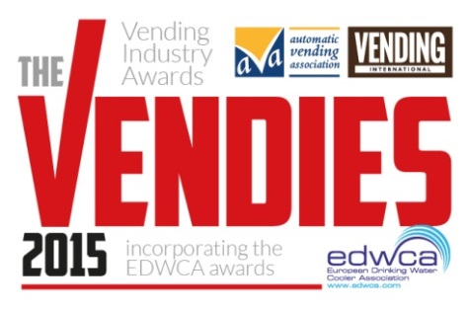
The Vendies 2015
Entry Form
Individual Awards

Section 1: Your details (simply type over the grey area)

First name |  | Surname
Job title
Company
Address
 |  | Postcode
Telephone
E-mail

Section 2: Categories: (tick all that apply)

Route Operator of the Year
Service Engineer of the Year
Lifetime Achievement Award
Awarded to a ‘friend of vending’ – someone who has been in the industry at least ten years and who has made a significant contribution to the vending industry, over and above the call of duty.

Section 3: Supporting material

Please detail the reasons why you feel the person you are nominating/you should win the award. You may wish to include an example of an instance they/you went above and beyond expectations, dealt with a difficult situation or problem, and how they/you stand out from the rest.

Route Operator of the Year  Name of Entrant:  Company: |  | Insert image below as hi res jpeg (300dpi or min 1mb)
Entry Statement (max 500 words):

Entries must be received by March 27th 2015

Please provide 2 customer testimonials (max 300 words each)

Testimonial 1 |  | Testimonial 2

Service Engineer of the Year  Name of Entrant:  Company: |  | Insert image below as hi res jpeg (300dpi or min 1mb)
Entry statement (max 500 words):

Please provide 2 customer testimonials (max 300 words each)

Testimonial 1 |  | Testimonial 2
www.thevendies.co.uk
2015 Entry Form
Individual Awards
Individual Awards

Lifetime Achievement Award  Name of Entrant:  Company: |  | Insert image below as hi res jpeg (300dpi or min 1mb)
Entry statement (max 500 words):

Please provide 2 customer testimonials (max 300 words each)

Testimonial 1 |  | Testimonial 2

Thank you for entering The Vendies 2015!
Please return completed forms to gmoore@datateam.co.uk by Friday 27th March 2015.
If you have any queries, please do not hesitate to contact me on 01622 699183.

Good luck!

Bryony Andrews
Features Editor
Vending International
www.thevendies.co.uk
2015 Entry Form
Individual Awards

